Customer Churn Analysis: Executive Summary
Source: CHURN_DATASET.xlsx | 1,388 of 1,500 rows retained after cleaning | 1,282 customers modelled | Prepared for Product and Marketing
Recommendation: do not deploy a churn model built on this dataset.
Every model tested scores at chance level (ROC-AUC 0.498 to 0.524 against 0.500 for a coin flip), so a high risk customer list drawn from it would be a random sample of the customer base. Retention budget spent against it would be wasted, and the team would be acting on false confidence. The work to do first is data collection, not modelling.
0.524 | 0.067 | 0.069 | 0 / 33 | 48.0%
Best cross-validated  ROC-AUC (chance = 0.500) | p-value against  randomly shuffled labels | Strongest feature  correlation with churn | Features reaching a  usable effect size | Churn rate among  labelled customers
Key findings
- Every model performs at chance. Six model families were cross-validated on identical folds: logistic regression, decision tree, k-nearest neighbours, random forest, gradient boosting and XGBoost. All six land between 0.498 and 0.524 ROC-AUC, where 0.500 is a coin flip.
- The model cannot be told apart from one trained on random labels. The tuned pipeline was retrained 30 times on deliberately shuffled churn labels. Those runs reach 0.540 at their 95th percentile; the real model scores 0.539, inside that range (p = 0.067). This rules out a coding error.
- Sixty trials of tuning made it worse. Optuna raised the cross-validated score from 0.524 to 0.539 while the held-out test score fell from 0.463 to 0.453. The two moving in opposite directions is the signature of fitting noise rather than signal.
- Tuning the alert threshold does not rescue it. The optimal cut-off flags 98% of customers and scores F1 0.651, against 0.647 for contacting everyone with no model at all. Its precision, 0.484, is simply the churn base rate.
- No feature carries signal, before or after engineering. 23 features were engineered, including recency, dormancy, spend per login and lifetime value. Not one of the 33 numeric inputs reaches a correlation of 0.10 with churn.
- Tenure and inactivity are flat, which is itself the red flag. These are normally the strongest churn predictors in any subscription business. Here churners and retained customers have identical tenure, 42.15 against 42.10 months (p = 0.98). Real customer data does not behave this way.
Business recommendations
- Do not deploy this model or fund a campaign from its scores. A high-risk list drawn from it is a random sample of customers. The wasted spend is recoverable; the false confidence is the more expensive part.
- Do not act on the feature rankings either. SHAP, permutation importance and the logistic coefficients each return a confident top-five list, and the three disagree with each other. An importance ranking always returns something, even when nothing is predictive.
- Fix the measurement first. Agree an operational definition of churn, for example no purchase in 90 days or an explicit cancellation, and record when it happened and why. The current label is a single flag with no date and no reason.
- Collect behaviour over time, not one snapshot. A per-customer event history of sessions, orders and support contacts makes trend features possible, such as spend down 40% over three months. Those are the features that carry signal in real churn work.
- Add the missing commercial and friction signals: payment history and failed payments, refunds and delivery problems, ticket resolution time and sentiment, discount exposure and price changes. Failed payments and unresolved tickets are typically among the strongest predictors and are absent here.
- Until then, use rules rather than a model. Triggers such as a failed payment, a ticket unresolved past its service level, or 60 days of inactivity are transparent, need no training data and are more defensible than a model at chance.
Limitations and next steps
- Sample size sets a floor on what is detectable. With 1,282 labelled customers, a genuinely weak but real driver could exist and still not reach significance. The finding is that no usable signal exists at this sample size.
- The data is a single snapshot with no time dimension, so trend and recency-of-change features cannot be built at all. Nine columns required imputation, and 106 customers had no churn label and were held out rather than imputed.
- Next steps, in order: instrument the churn event, backfill six to twelve months of event history, then re-run this pipeline unchanged. The label-shuffle test is the gate to apply: if the real score does not clear the shuffled-label distribution, the model is not ready.
- Worth confirming whether this dataset is synthetic. Flat tenure, uniform categorical splits and 30 identical repeated extreme values across three columns are all consistent with generated data. If so, the pipeline is validated and ready for the real extract.
Full analysis and diagnostics: churn.ipynb. Stratified 5-fold cross-validation on 1,025 training customers, scored once on 257 held out. ROC-AUC is the headline metric because the classes are near balanced, so majority-class accuracy already reaches 52%.

Supporting evidence
Every chart below is output from the analysis notebook, churn.ipynb, produced by the run this summary reports.
1. Tenure does not separate churners from retained customers
In a subscription business, how long a customer has been active is normally the single strongest churn predictor. Here the two distributions sit on top of each other: 42.10 months average tenure for retained customers against 42.15 for churners, p = 0.98. The band chart on the right is not monotonic, so the swing between bands is noise rather than a trend. This flatness is the first sign that the dataset does not behave like real customer data.
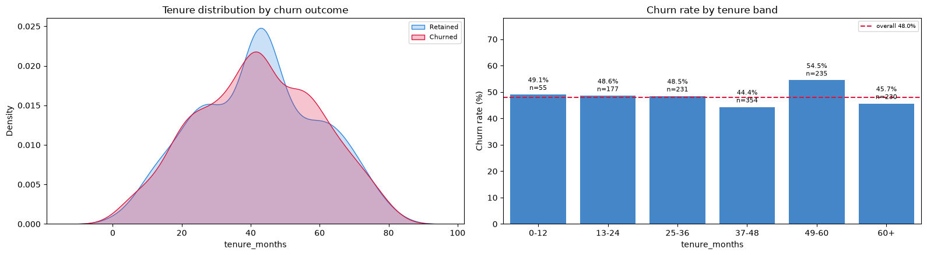
churn.ipynb, churn behaviour analysis
2. No feature reaches a usable correlation with churn
23 features were engineered on top of the raw columns, including recency, dormancy ratio, spend per login and estimated lifetime value. A feature generally needs a correlation of about 0.10 before it carries usable predictive weight. The strongest here is used_mobile_app at 0.069, and 0 of 33 numeric inputs clear the line.
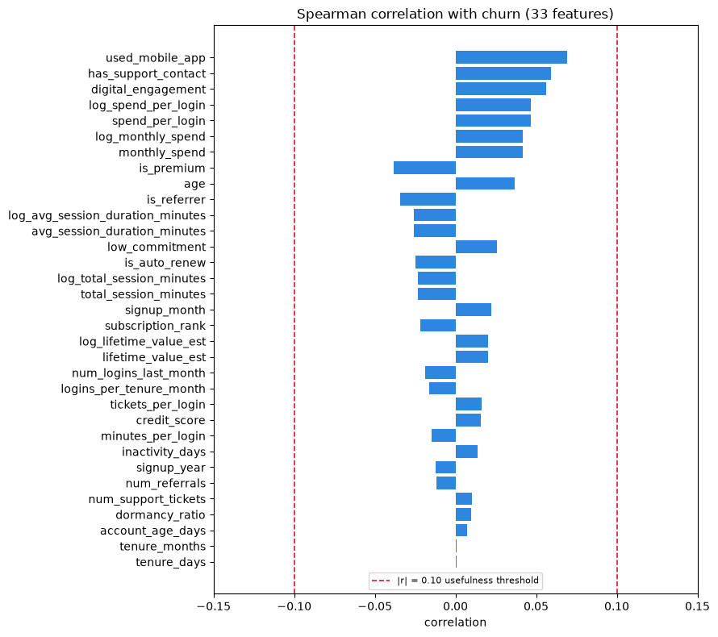
churn.ipynb, feature engineering
3. All six models land at chance
Six model families were cross-validated on identical folds with identical preprocessing. All six fall between 0.498 and 0.524 against the 0.500 dashed line, which is a coin flip. The error bars, one standard deviation across folds, are wider than the gap between the best and worst model. Models that learn in completely different ways do not agree this closely unless there is nothing in the features to learn from.
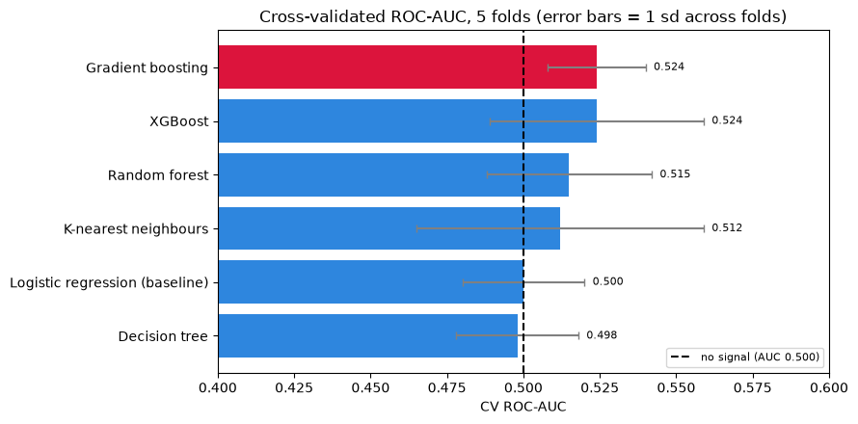
churn.ipynb, model training and evaluation
4. Sixty trials of tuning improved the score it could see and worsened the one it could not
Left: every Optuna trial, with the running best in red. The trials scatter around the 0.500 no-signal line and never pull away from it. Right: cross-validation rose from 0.524 to 0.539 while the held-out test score fell from 0.463 to 0.453. Taking the best of 60 noisy scores lands near the top of the noise by construction. The two bars moving in opposite directions is the signature of fitting the folds rather than the data.
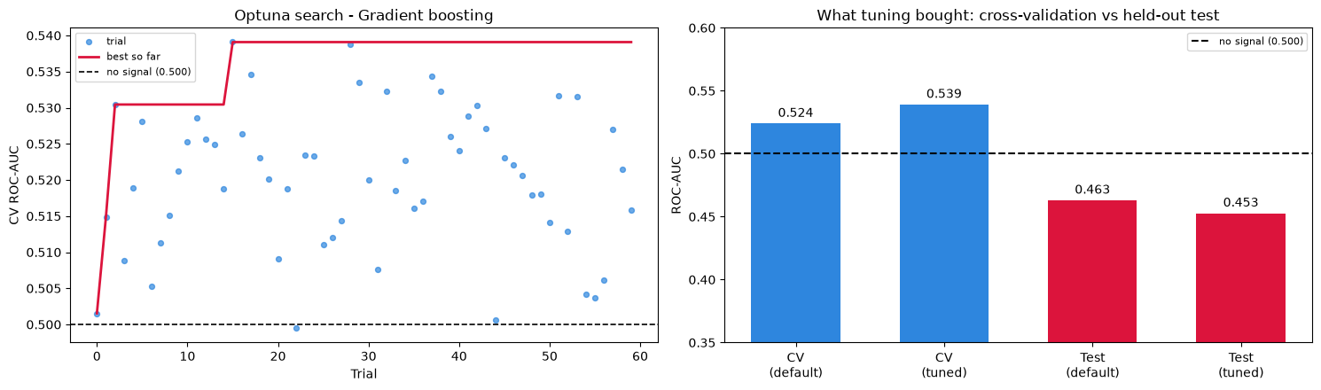
churn.ipynb, hyperparameter tuning
5. Moving the alert threshold cannot buy predictive power
The threshold was selected from out-of-fold predictions, so the test set stayed untouched. The blue precision line sits flat on the orange base-rate line across the whole range, meaning that whatever cut-off is chosen, the flagged group holds the same proportion of churners as the customer base does. Both objectives return 0.05, which flags 98% of customers and scores F1 0.651 against 0.647 for contacting everyone with no model at all.
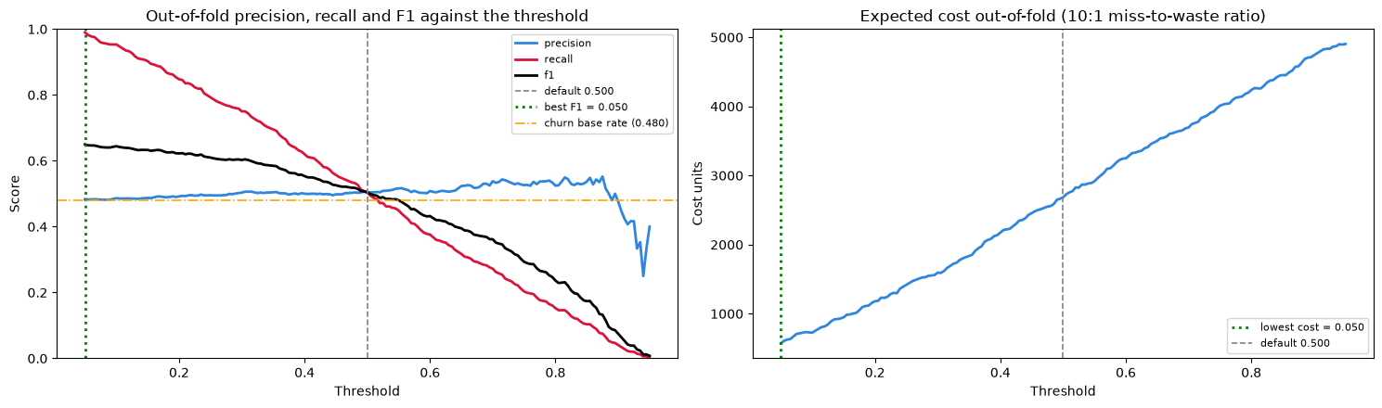
churn.ipynb, choosing the decision threshold
6. The tuned model cannot be told apart from one trained on random labels
The decisive test. The same tuned pipeline was retrained 30 times on deliberately shuffled churn labels, producing the blue distribution. The real model, the red line at 0.539, sits inside that distribution rather than to the right of it, below the 95th percentile of 0.540 (p = 0.067). This rules out a coding error and locates the problem in the data. If a future dataset is tested, this is the gate to apply before deploying anything.
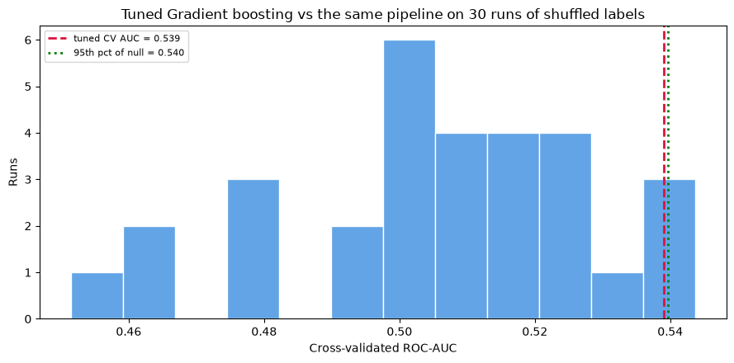
churn.ipynb, label-shuffle test
What these six charts add up to
Charts 1 and 2 show the problem is in the data: the variables that normally predict churn are flat here, before any model is involved.
Charts 3 and 4 show it is not a modelling failure: six different model families and sixty tuning trials all land in the same place.
Charts 5 and 6 close off the two remaining escapes: the alert threshold cannot buy predictive power, and the result cannot be told apart from random labels.
The recommendation on page 1 follows from this: collect the missing behavioural data, then re-run the notebook and apply chart 6 as the go or no-go test.

